

**Electronics and digital circuits**

**Module Leader:** DR. Khaled Abdelgaber.

**Project Title:** HEART BEAT SENSOR CIRCUIT

**Group: (A4T1)**

**INTRODUCTION:**

This paper has been developed to design an accurate and efficient heart rate monitoring project that can be used to measure and analyze heartbeats using electronics and circuits. In the construction of the system, components such as resistors, capacitors, diodes, and ICs are used to implement a breadboard; the breadboard is a physical prototype of the heart rate monitor which is real-time. Resistors comprise R1, 47 Ω, which offers the base impacting on current; R2, 5.6 kΩ; and R3, 10 kΩ, affecting the collector’s current adjusting with RV1, 100 kΩ, a potentiometer. Capacitors C1 with 68nF value and C6 with 2.2µF are placed to provide stability and filter signals in the circuit.

The project uses a 555 timer Integrated Circuit to create pulses as well as the timing circuits for the project; on the other hand, a 741 operational Amplifiers are used to increase the signal strength of the heartbeat signal. Various diodes are used, and a Zener diode of 1N4372A are employed to fix the voltage, while red color LED is utilised to signify the heart beating patterns. There is an NPN transistors, 2N6547, that evacuate and toggle the inputs, and the output equipment includes a buzzer, BUZ1, that produces sound each time it captures heartbeats.

Due to the modularity of the circuit the design can be changed and scaled making it useful in educational demonstrations and proof of concept designs. This project is constructed using a large breadboard with jumper wires, bringing together individual components of an electronic system to make a real-life application for biomedical technology, demonstrating the values of what simple components can do in using an electronic system to perform a complex and effective function.

**Description of the objective:**

This electronic project is designed to sense the human heartbeat using a pulse sensor placed on the finger. The sensor detects the pulse and generates an analog signal, which is sent to the input of an integrated circuit (IC). The IC processes the signal, and its output is connected to an active buzzer. The buzzer produces a beep in sync with the heart's rhythm, providing auditory feedback of the heartbeat.

**Schematic of the circuit:**

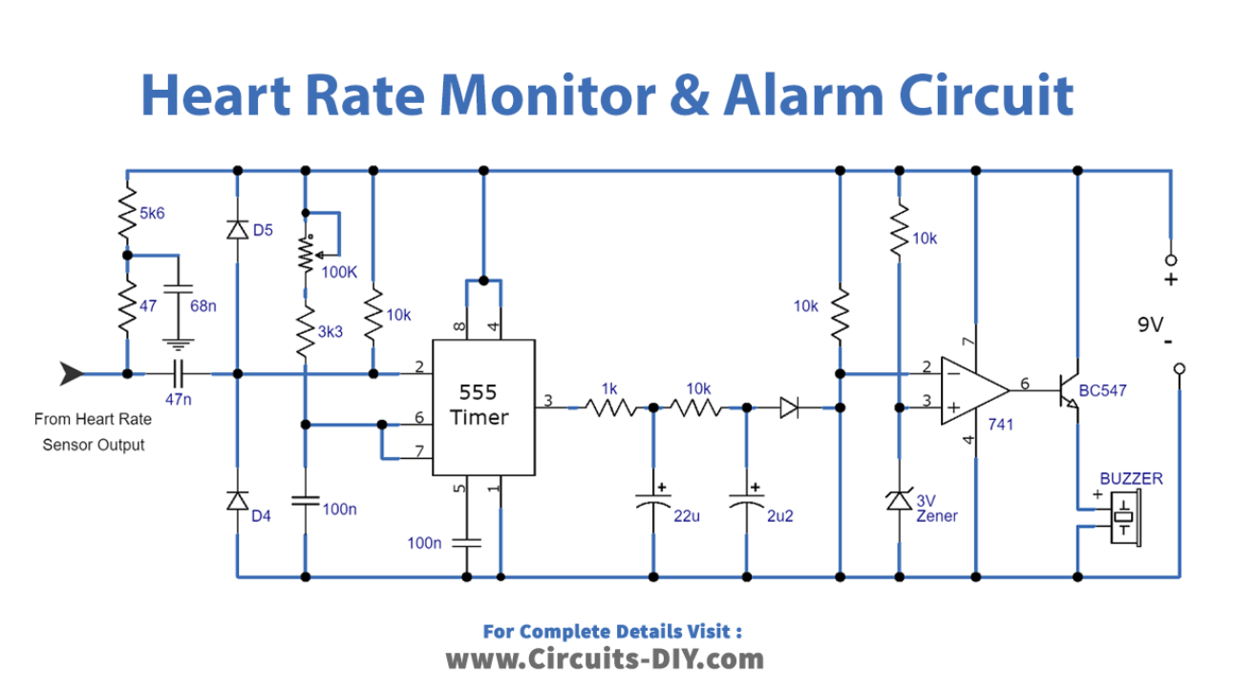

**Components**

**Resistors**

* R1: 47 Ω
* R2: 5.6 kΩ
* R3: 10 kΩ
* R4: 1 kΩ
* R5: 3.3 kΩ
* R6: 10 kΩ

**Potentiometer**: RV1 (100 kΩ adjustable resistor)(variable resistors).

**Capacitors:**

* C1: 68 nF
* C2: 22 µF
* C3: 47 nF
* C4: 100 nF
* C5: 100 nF
* C6: 2.2 µF

**Diodes:**

* D1: LED (Red)(3 leds).
* D2, D3, D4: General-purpose diodes
* D5: Zener diode (1N4372A) (3v).

**ICs:**

* U2: 555 timer IC
* U3: Operational amplifier (741 op-amp)

**Transistor**:

* Q1: 2N6547 (NPN transistor)

**Buzzer:**

* BUZ1 (sound output).
* **bread board**
* **Battery 8.5 volts**
* **jumper wires**
* **5v power supply.**
* **Pulse Sensor module**
* **Pulse sensor module**: It is used to sense the pulse from the finger. This sensor gives an analog signal to the input of the IC whether there is a pulse or not, and it is considered one of the most important components of the circuit.
* **Visual Feedback:** one red LED is used in the circuit to provide a visual feedback mechanism. The red LED lights according to the rhythm of the person’s heartbeat and if there is no pulse to read the red LED will be working nonstop.

* **Auditory Alert System:** The circuit has a buzzer-powered auditory alert system in addition to visual indicators. The buzzer works with the red LED when there is pulse the buzzer will beep according to the rhythm of the heartbeat and when the pulse stops the buzzer will keep beeping to alert the person that there is no pulse. This dual feedback system makes sure that warnings are given to drivers clearly and promptly.

**Theoretical analysis**

**We examined the mechanisms by which the heartbeat sensor circuit's components function in order to gain a better understanding of how each one is necessary to achieve its goal.**

**Resistor:** 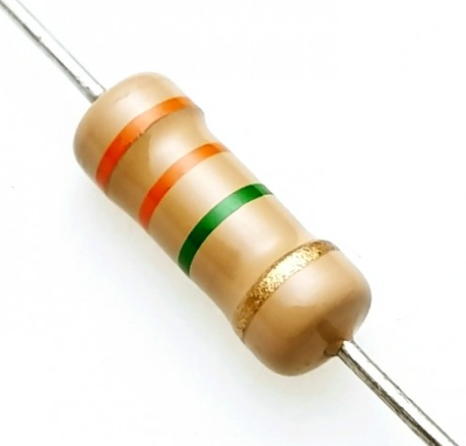

* An electrical component that restricts or controls the passage of current in an electronic circuit is called a resistor. Resistors can also be used to supply an active device, such a transistor, with a particular voltage.

**Potentiometer:**  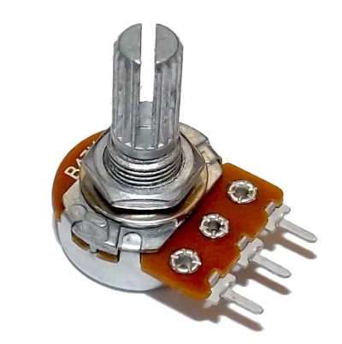

* A potentiometer is a three-terminal resistor with a sliding or rotating contact that forms an adjustable voltage divider. If only two terminals are used, one end and the wiper, it acts as a variable resistor or rheostat.

**Capacitor:** 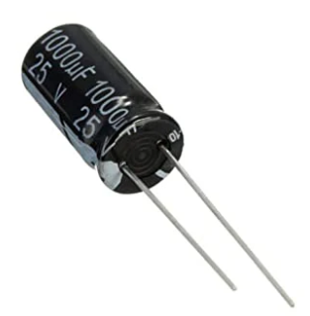

* Is a device that uses one or more pairs of conductors spaced apart by an insulator to store an electric charge.

**Diodes:** 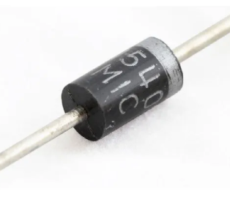 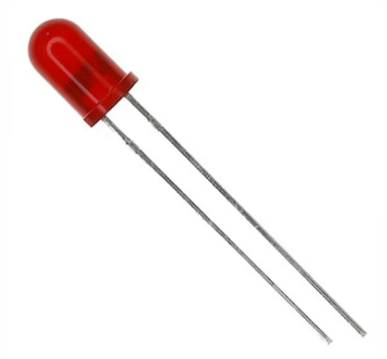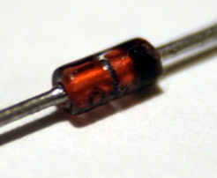

* A semiconductor device known as a regular diode functions as a one-way switch for electrical current. It will prevent current from flowing in one direction while permitting it to flow in another.
* **LED Diode** : is a diode that emits light when the current is passed through it
* **Zener diode** : Zener diodes are semiconductor devices that allow current to flow in both directions but specialize in current flowing in reverse.

**ICs :** 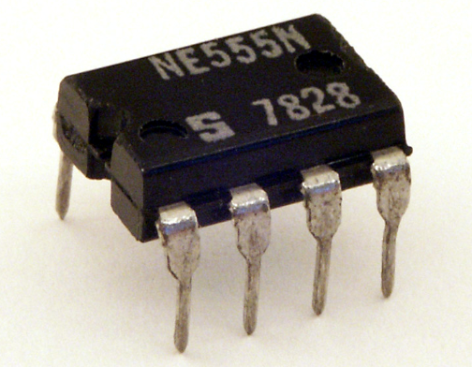

* **1. 555 Timer IC (U2):**

The 555 timer IC in this circuit is configured as a monostable multivibrator. It serves as a pulse-shaping component that converts the irregular and weak pulses coming from the heartbeat sensor (HB1) into clean, uniform-width pulses. Here's a detailed breakdown of its function:

Monostable Multivibrator Configuration

In this configuration:

Pin 2 (TR - Trigger): Receives the input signal from the heartbeat sensor. When a heartbeat is detected, this pin is pulled low, triggering the timer.

Pin 3 (OUT): Outputs a single, clean pulse of a fixed duration when the timer is triggered.

Pin 6 (TH - Threshold) and Pin 7 (DC - Discharge): Work together to control the pulse duration based on the timing components (resistor RV1 and capacitor C4).

Pin 4 (R - Reset): Connected to the power supply to keep the timer enabled.

Pin 5 (CV - Control Voltage): Connected to ground through a small capacitor (C5) to stabilize the timer operation and filter noise.

Operation of the 555 Timer in the Circuit

Heartbeat Trigger:

The heartbeat sensor (HB1) generates weak, irregular pulses as it detects heartbeats.

These pulses are fed to the trigger input (Pin 2) of the 555 timer.

Pulse Generation:

When the trigger input goes low (below 1/3 of the supply voltage), the 555 timer triggers and outputs a single pulse on Pin 3.

The output pulse is of a fixed width, determined by: T=1.1×RV1×C4T

RV1 (100kΩ): Variable resistor to adjust the pulse duration.

C4 (100nF): Timing capacitor.

Output:

The output at Pin 3 is a clean, rectangular pulse that lasts for the calculated duration. This pulse is fed to the 741 op-amp for further processing.

Purpose:

The 555 timer cleans up the noisy signal from the heartbeat sensor.

It produces a consistent pulse for each detected heartbeat, making it easier to process in the next stage.

* **Operational Amplifier:** **741 Operational Amplifier (U3):**

The 741 op-amp is configured as a comparator in this circuit. Its role is to compare the processed pulse from the 555 timer with a reference voltage and provide a clear high or low signal. This signal drives the transistor switch, activating the buzzer and LED.

Comparator Configuration

The op-amp has two inputs:

Non-inverting input (+): Receives the pulse signal from the 555 timer (Pin 3 output).

Inverting input (-): Receives a fixed reference voltage created by a voltage divider network (R3 and R6).

Output:

The output of the op-amp goes high when the voltage at the non-inverting input (+) exceeds the reference voltage at the inverting input (-).

Operation of the 741 Op-Amp in the Circuit

Reference Voltage:

The reference voltage at the inverting input (-) is set using resistors R3 and R6 (10kΩ each) as a voltage divider: Vref=Vcc×R6R3+R6V

​ This provides a stable threshold voltage for comparison.

Pulse Comparison:

The pulse signal from the 555 timer is fed to the non-inverting input (+).

When this pulse voltage exceeds the reference voltage, the op-amp output goes high.

Output to Transistor:

The high output of the op-amp is used to turn ON the transistor Q1 (2N547 NPN transistor).

This allows current to flow through the buzzer (BUZ1) and LED (D1), activating both as indicators of a detected heartbeat.

Purpose:

The op-amp acts as a threshold detector or comparator.

It ensures that only valid pulses (those exceeding the reference voltage) trigger the output stage.

This stage eliminates any noise or unwanted small signals that might falsely trigger the indicators.

* **Transistor :** 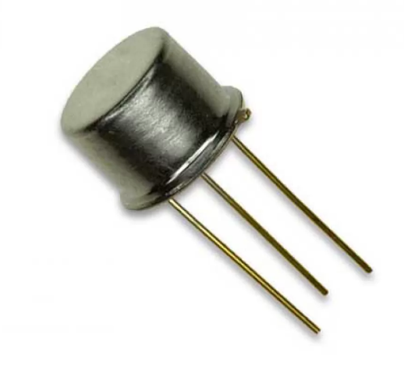

The transistor functions as a switch to control the operation of the buzzer and LED. Here’s how it works:

Base Drive:

The output of the 741 op-amp (U3) is connected to the Base of the transistor.

When the op-amp output goes high (greater than 0.7V), it provides enough voltage and current to turn ON the transistor.

Transistor ON State:

When the transistor is turned ON:

Current flows from the Collector to the Emitter.

This allows current to flow through the buzzer (BUZ1) and the LED (D1), activating them.

The transistor acts as a low-resistance path between the buzzer and ground.

Load Activation:

The buzzer emits a sound, and the LED glows, providing audible and visual feedback that a heartbeat has been detected.

Transistor OFF State:

When the op-amp output is low, there is no Base current.

The transistor remains OFF (non-conducting), and no current flows through the buzzer or LED.

**Buzzer :** 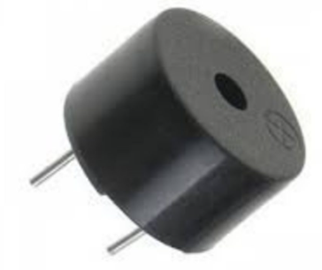

* A buzzer is a basic audio device that generates a sound from an incoming electrical signal.

**Simulation results:**

The results from the heart rate circuit simulation indicated that it was really effective in identifying the heartbeats and providing feedback. The circuit employed operational amplifiers, such as the U3, 741 op-amp, to amplify the weak signals from the pulse sensor and 555 timer ICs (U2) to generate steady pulse outputs. For voltage regulation, Zener diodes D5, 1N4372A were used and for filtering the signals capacitors C1 of 68nF and C6 of 2.2µF were used. An active buzzer (BUZ1) was used to produce beeping sound that was in sync with the heartbeat and provided an audio feedback. There was also a 100 kΩ potentiometer (RV1) which was used to adjust the sensitivity of the circuit, thus making it easy to set.and also LED lights to show a visual signals.This circuit provides both visual and sound signals to help detect heartbeats. It's easy to adjust and doesn't need a microcontroller, making it a flexible and useful option for many different uses.

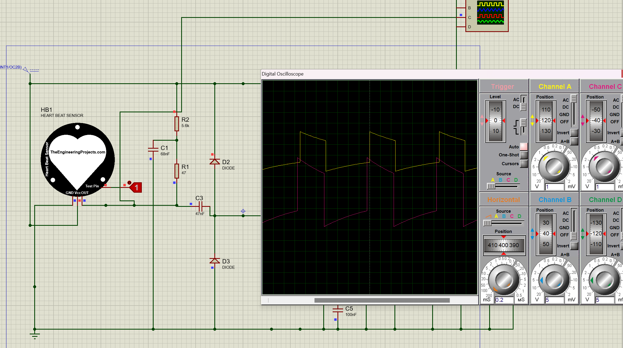

**Conclusion:**

The heartbeat sensor circuit is an important electronic device which provides accurate heart rate monitoring. This equipment is encouraging wider application in both personal health and technology. Some of its applications include:

Medical Monitoring: It finds its wide applications in hospitals and health gadgets to monitor the heart rates of patients.

Sports Coaching: During practice sessions these sensors are used by coaches and trainers to monitor athletes heart rate and to allow a proper recovery regimen after performance.

Mental Health Applications: A number of mindfulness and meditation applications include heartbeat sensors helping users monitor their physiological reactions and practice relaxation techniques.

Public Health Initiatives: Used in programs aimed at enhancing the health of communities to measure the incidence of heart-related events and contribute to the cardiovascular disease prevention and control research.

**Elaboration and Comments on All Results:**

Further justification of the heartbeat sensor circuit is done by showing the simulated results. The green LED and the buzzer serve as indications that the circuit is functioning properly. These indicators are pulsating together, similar to a heartbeat; this means that the sensor is measuring the heart rate of the user. More importantly, it provides real-life feedback to the user about their health condition in the cardiovascular aspect.

Operating Voltage: The circuit has been run on a quite stable 9-volt battery and a 5-v sensor throughout its life. The main purpose of this circuit is to immediately provide the user with insight into their heart rate, whether irregular or normal. This is important in both health monitoring and fitness optimization, since it allows users to make informed decisions about their physical activities and health management. Overall, the heartbeat sensor circuit is a big plus in personal health technology.

**Diffculties and trouble shooting:**

* Some problems were faced during the software implementation of the circuit on proteus.
* the simulation was done on proteus and proteus doesn’t have the heart rate sensor in its components, so we had to look for a library and download it to use the component in proteus.
* Some components were very hard to find like the heart rate sensor so we had to order it online.
* The transistor used in the simulation (2n6547) wasn’t available in Egypt so we tried many transistors in the simulation app untill we found an alternative(2n3055) and after a consultation from the module leader he recommended us to use the BC547 transistor.

References

Nawazi, F. (2024, July 30). *How to build a heart rate monitor & alarm circuit*. Circuits DIY.

<https://www.circuits-diy.com/how-to-build-a-heart-rate-monitor-alarm-circuit/>

Fairchild Semiconductor Corporation. (2002). LM555 Single Timer. In *LM555 Single Timer* (Rev. 1.1.0, Vols. 1–3, p. 1) [Book]. <https://www.onsemi.com/pdf/datasheet/lm555-d.pdf>

Texas Instruments Incorporated. (1998). LM741 Operational Amplifier. In *LM741* (REVISED OCTOBER 2015) [Technical documentation]. <https://www.ti.com/lit/ds/symlink/lm741.pdf?ts=1710513309861&ref_url=https%253A%252F%252Fwww.google.com%252F>

Matsusada Precision Inc. (n.d.). *Capacitor’s Roles and Mechanisms | Tech | Matsusada Precision*. Matsusada Precision. <https://www.matsusada.com/column/capacitor.html>